Internship Report

IMS Infrastructure Department

Reliance Jio

Navi Mumbai , India



10th May 2017 - 15th July 2017

Mentors : Birendra Bisht , Nitin Warape

Reviewer : Atul Agrawal

*Submitted By :*

DIVYANI MITTAL

B. Tech. III year Computer Engineering

National Institute of Technology , Surat

Surat , India.

Contents :

1. Preface
2. Acknowledgments
3. Reliance Jio Introduction
4. Abstract

[ PROJECT – 1 ]

1. BTAS Introduction

A . CDR File Generation

B. Clear Code Parameter

6. CDR Analysis Without Automation

7. CDR Analysis With Automation

8. CDR Success Rate and Failure Code Analysis

[ PROJECT – 2 ]

9. Demo WebRTC

10. Demo Socket.IO

11. Understanding SIP

12. Conclusion

13. References

**PREFACE**:

This report documents the work done during summer internship at IMS

Infrastructure Department of Reliance Jio C-Wing TC-23 4th Floor in Ghansoli , Navi Mumbai , India under the supervision of Birendra Bisht Sir and Nitin Warape Sir during 10th May 2017 to 15th July 2017.The report first shall give an overview of the Reliance Jio its RJIO Infrastructure including the BTAS System , the need of the project and the task completed during the period of internship with its technical Details.Then the results obtained shall be represented and analyzed.

Report shall also elaborate on the the future works which can be persuaded as an advancement of the current work.

I have tried my best to keep report simple yet technically correct. I hope

I succeed in my attempt.

Divyani Mittal

**Acknowledgments** :

“ Our ambitions higher.Our 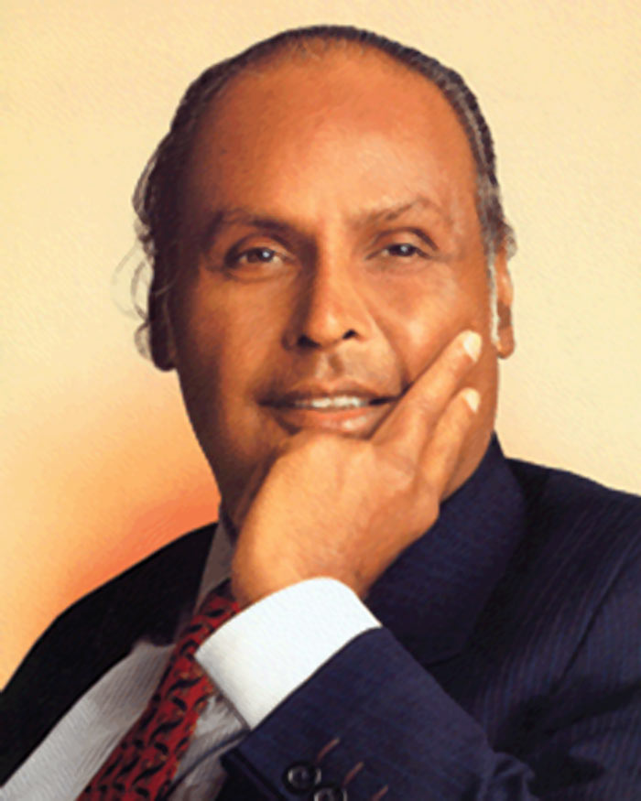

commitment deeper.And our

efforts greate .This is my

Dream for Reliance

And for India. “

---Dhirubhai Ambani---

Highly Motivated by the dream of Dhirubhai Ambani and with lots of help I received cheerfully from whole BTAS Team of IMS Infrastructure Department I could successfully execute my project . The work culture in Reliance Jio really motivates.

I would specially thank Nitin Warape Sir , Birendra Bisht Sir , Shashi Sir for helping to debug my project.Listening to their discussions developed a good interest in telecom industry. I also thank Preti Kelkar Mam who seemed to have solutions to all my problems.

Divyani Mittal

**RELIANCE JIO INTRODUCTION :**

**Reliance Jio Infocomm Limited**, or **Jio**, is an [LTE](https://en.wikipedia.org/wiki/LTE_(telecommunication)) [mobile network operator in India](https://en.wikipedia.org/wiki/Mobile_network_operators_of_India). It is the only “VOLTE-only” (Voice over LTE) where LTE means Long Term Evolution operator in the country.

Jio means TO LIVE and to BE ALIVE. To every opportunity and realize the potential of every Indian.Jio is a movement that will empower 1.3 billion Indians.

Jio is an entire ecosystem that will allow Indians to live Digital Life to the fullest. The Jio ecosystem stands tall on FIVE fundamental pillars:

1. The best quality broadband network with the highest capacity

2. A world of affordable, 4G smartphones and wireless IP devices

3. Compelling applications and content

4. Superior digital service experiences, and

5. Affordable and simple tariffs

The initiative are truly aligned with the government India’s ‘Digital India’ vision for our nation.

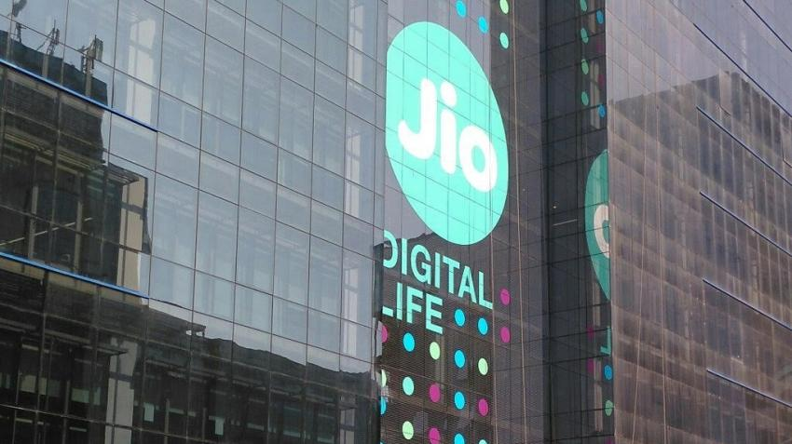

**ABSTRACT :**

The report represents two Projects completed during internship in Reliance Jio are Listed Below :

1. Development of Utility Tool To Automate BTAS CDR

Analysis

2. Understanding Functionality of WebRTC Socket.IO &

SIP.

All the tasks has been completed successfully and results were

according to expectations.

Acronyms Used :

BTAS Business Telephony Application Server

CDR Call Detail Record

IMS IP Multimedia Subsystem

IP Internet Protocol

NE Network Element

**BTAS INTRODUCTION :**

BTAS - Business Telephony Application Server

The BTAS system is a core part of RJIO Infrastructure.

BTAS System generates Call Detail Record (CDR) for every call which passes through it. These Call Detail Records can be exported to external entities using different mechanisms. BTAS system generates a CDR on call completion. CDR Fields information is available in Comma Separated Values .

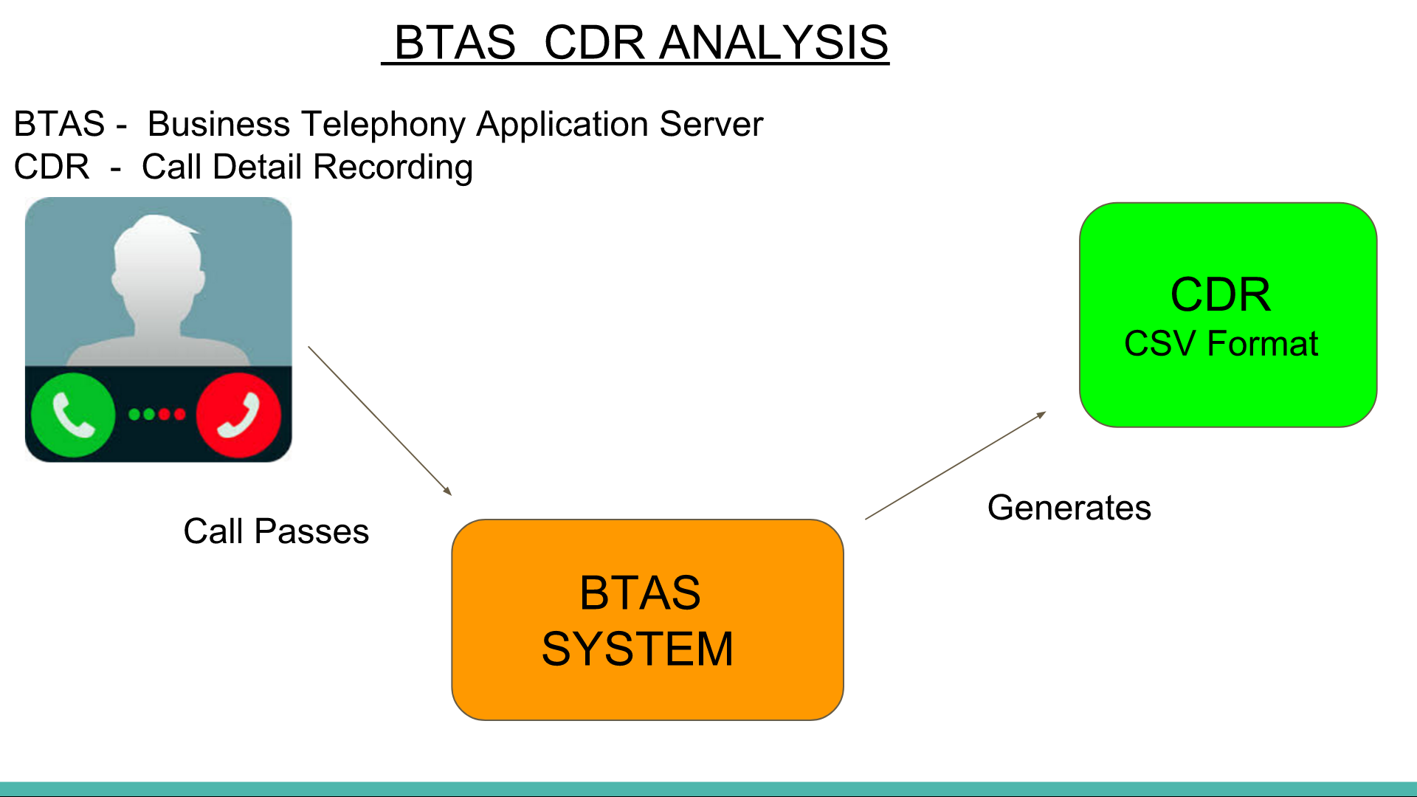

CDR File Generation :

BTAS System is composed of multiple blades which hosts call processing modules. These calls processing modules handles the call and sends Call Details Record related information to CDR Manager. These call processing module and CDR Managers are functional on each of multiple blades and therefore, CDRs get generated on each of blade.

CDR file is generated in ACTIVE server of a service group only.

** HAS MULTIPLE CLUSTER

EACH CLUSTER : May be 1 blade , 2 blade or 6 blade setup

C1 C2 P1 P2 P3 P4

C1 & C2 = Controllers ACTIVE OR STANDBY

P1 , P2 ,P3 & P4 = Payloads ACTIVE OR STANDBY

OUTPUT DIRECTORY PATH :

BTAS generates CDRs at output folder given by location *$COMMON_OUTPUT_PATH/chrg/online/cdrs/*.

CDRs get generated in file whose filename convention is as follows:

BTAS_XXYYCCZZ_CB_YYYYMMDDHHMMSS_XXXX_<pid>.Extension

Here timestamp YYYMMDDHHMMSS in file name indicates the time when CDR files got closed.

CDR files with extension *.active is created in ACTIVE server of the service group only. STANDBY server doesn’t create any *.active CDR file.Our analysis is completely based on *.csv extension files.

Example of CDR in BTAS :

*2,1.0.1,mum-btas1.ims.mnc862.mcc405.3gppnetwork.org,tel:+919872001677,sip:+919872001677;npdi;rn=3093@ims.mnc862.mcc405.3gppnetwork.org;user=phone,sip:+919872001093@ims.mnc862.mcc405.3gppnetwork.org,tel:+919872001093|sip:+919872001093@ims.mnc862.mcc405.3gppnetwork.org,03082017173717977,03082017173750148,03082017173756414,6266,1,0,"USER DISCONNECTED",,1,0,94db32339b795f3f4e2a66280a73fd1e,Lkg9glHmCAk5JJVw6yU,sip:+919872001093@ims.mnc862.mcc405.3gppnetwork.org,,{[0]:<m=audio 7112 RTP/AVP 98 97 101 102 |{[0]:b=AS:41[1]:a=rtpmap:98 AMR-WB/16000[2]:a=rtpmap:97 AMR/8000[3]:a=rtpmap:101 telephone-event/8|1|||||0>},,2100200200,1,ims.mnc862.mcc405.3gppnetwork.org,3GPP-E-UTRAN-TDD;utran-cell-id-3gpp=40586200000006011,npdi;rn=3093,1234,5678,1,,,0,,,,0,,0*

There are total 41 parameters printed in CDR .csv files.Out of 41 parameters the below parameters are used in implementing automation :

|  |  |  |  |
| --- | --- | --- | --- |
| **Field No** | **Field Name** | **Description** | **Data Type** |

|  |  |  |  |
| --- | --- | --- | --- |
| 4. | Original Called Number | Contains the Called Number which A Party has actually dialed | Alpha-Numeric |
| 5. | Modified Called Number | Contains the modified Called Number in case dialed called number has been altered | Alpha-Numeric |
| 6. | Original Calling Number | Contains the Original Calling Number | Alpha-Numeric |
| 7. | Modified Calling Number | Contains the modified Calling Number in case calling number has been altered | Alpha-Numeric |

|  |  |  |  |
| --- | --- | --- | --- |
| 8. | Call Initiation Time | Contains details of time when call establishment was initiated (up to millisecond)  Format: MMDDYYYYHHMMSSMMM  Where MM-Month, DD-Date, YYYY-Year, HH- Hour, MM-Minutes, SS- Seconds, MMM - milliseconds | Numeric |
| 9. | Call Start Time | Contains the time when call got successfully established (up to millisecond)  Format: MMDDYYYYHHMMSSMMM  Where MM-Month, DD-Date, YYYY-Year, HH- Hour, MM-Minutes, SS- Seconds, MMM - milliseconds | Numeric |
| 10. | Call End Time | Contains the time when call got disconnected (up to millisecond  Format: MMDDYYYYHHMMSSMMM  Where MM-Month, DD-Date, YYYY-Year, HH- Hour, MM-Minutes, SS- Seconds, MMM – milliseconds | Numeric |

|  |  |  |  |
| --- | --- | --- | --- |
| 12. | Call Answered Status | 0 – means not answered  1 – means answered | Numeric |

|  |  |  |  |
| --- | --- | --- | --- |
| 24. | Clear Code | Contains Clear-Code containing the detailed reason for disconnection of call. For further details, BTAS_Clear_Code document. | Alpha- Numeric |

CLEAR CODE PARAMETER

RJIO BTAS generates the Call Detail Record (CDR) for every call which is processed by the system. These CDRs contains information field like A-Party, B-Party, Call Initiation Time, Call Establishment Time, Call Duration etc. One of very important requirement in CDR is to precisely identify the reason of call failure using CDR Field.

Call may fail to number of reasons.

For example, Call may fail due to :

• error being received by BTAS from other network elements with which BTAS

communicates

• no service information or call routing information is configured at BTAS to route

the call

• Invalid Dialed number

• Calling Restrictions

• Call not answered or rejected by B Party

• some internal reasons inside BTAS

BTAS fulfils this requirement of precise failure cause identification using ‘Clear Code’, which is nothing but a 10 digit integer code which pin points exact reason of call failure. Clear Code value is dumped as one of the field (Field Number: 24) in Call Details Record.

Using Clear Code, one can easily identify:

• Whether call failed due to external reason i.e. error response being received from

other network elements

• On which specific network interface and protocol , error was received from

external source

• Exact error code received from external source

• Exact SIP response message sent by BTAS in SIP call setup messages

• Call got disconnected due to BYE received from network

• Call failure due to response timeout at network node

• Details of Source Module name inside BTAS incase call failure was triggered

internally.

CLEAR CODE FORMAT :

a) BTAS ‘Clear Code’ is a 10-digit code

b) First digit signifies whether call failed due to error code received from external

source or due to call processing inside BTAS.

a. 1xxxxxxxxx means that call failed while processing the call at BTAS -

Internal Error.

b. 2xxxxxxxxx means the call failed due to error received from external

source - External Error.

c) In case of External Error, Second and Third digits together signifies the network

interface & protocol on which error is received from External Error. Otherwise, for

Internal Error, second and third digits indicate the BTAS Module Name which

triggered the call failure.

d) Fourth, Fifth, Sixth and Seventh digits together signifies either internal error

generated from BTAS Modules or error received from external interfaces.

Possible values are listed in section 3 and 4 respectively.

e) Eighth, Ninth and Tenth digits together signifies the SIP protocol final response

sent to network by BTAS. Possible values are listed in section 3 and 4

respectively.

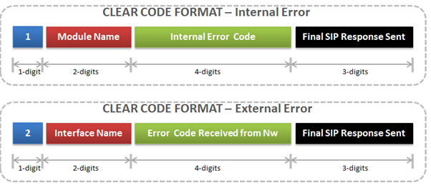

During implementation I focused on first digit to check whether it is internal or external error and depending on it extracted the 4 digit error code.Later in document I have discussed its analysis.

CDR ANALYSIS WITHOUT AUTOMATION :

Supposing there are 4 cluster in mumbai circle of each 6 blade . Inorder to find the csv file generated by a call on a particular phone number the analyst has to ssh into each and every blade , got to cdr path and using grep and findout command and other linux commands figure out the csv file containing the required call session .

If analyst need to figure the success rate of calls and analysis the error code of failure then also same procedure was followed additional grepping clear code of session to get error code.

It was very time consuming as each active blades files are in range of 10,000 and there will be total 24 blades in case all clusters are 6 blade setup. Thus , this process required urgent automation to speed up the work and make it more efficient.

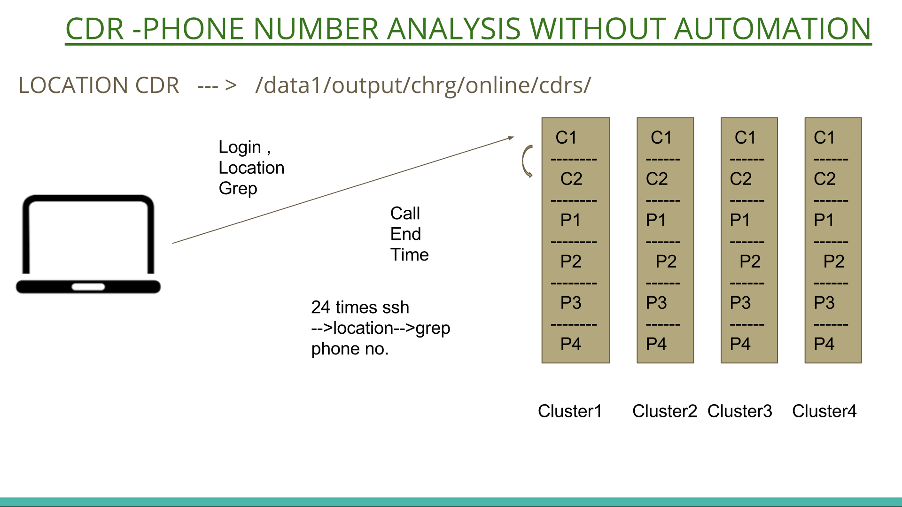

PROJECT -1

DEVELOPMENT OF UTILITY TOOL

TO AUTOMATE

BTAS CDR ANALYSIS

SCRIPTING : BASH

PART 01 :

CDR NUMBER ANALYSIS WITH AUTOMATION :

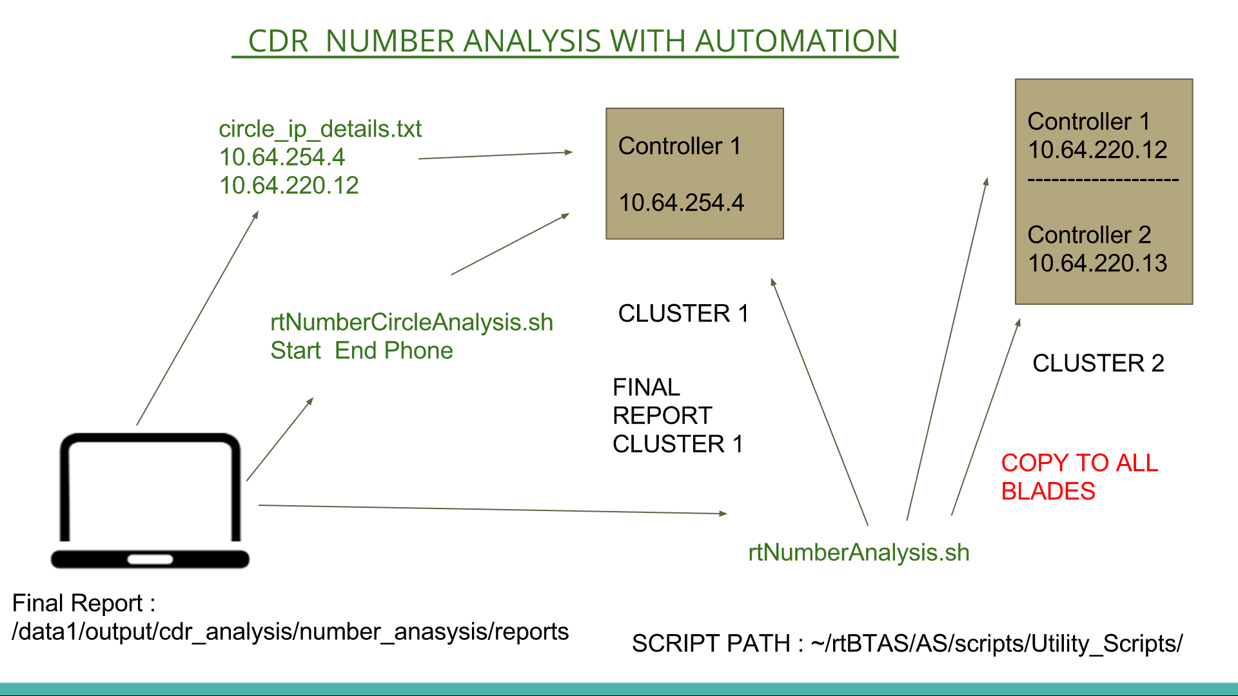

Execution By Analyst :

Supposing there are 2 clusters , cluster 1 is single blade and cluster 2 is 2 blade setup as shown above.

Analyst wants to analyse these two cluster for a phone number between specific duration.

Steps :

1. Analyst has to copy the rtNumberAnalysis.sh script to all 3 blades.

This will be done one time before executing.

2. Analyst will write the active controller ip of the all clusters where the

Script has to be invoked in the circle_ip_details.txt.

3. Analyst will execute the rtNumberCircleAnalysis.sh script in the controller

Where final report containing the result from all cluster will be shown.

4. Also there is an Autocomplete Custom Tab Completion Feature on tab

Press during the invoking of Script it provides hints for further arguments

to be supplied . Inorder to enable the custom tab completion copy the

rtBashrc.sh script to ~/.bashrc and source ~/.bashrc.

Parameters to be supplied as command line argument to invoke the script are :

1. GUI-ARGUMENT CHOICE : Enter 1 = GUI 2 = Argument

-- SELECTED 1 REDIRECT TO GUI / SELECTED 2 ENTER FURTHER

PARAMETERS --

2. RELATIVE-ABSOLUTE CHOICE : Enter 1 = Relative Time 2 = Absolute Time

-- SELECTED 1 ENTER BELOW PARAMETER --

3. MINUTES : Minutes to be Run from current time

4. PHONE NUMBER : Phone number to search [XXXXXXXXXXXX]

-- SELECTED 2 ENTER BELOW PARAMETER --

3. START_DURATION : Start time from where you want start analysis

[YYYYMMDDHHMMSSMMM]

4. END_DURATION : End time where to stop analysis [YYYYMMDDHHMMSSMMM]

5 . PHONE NUMBER : Phone number to search [XXXXXXXXXXXX]

NOTE :

1. The rtNumberAnalysis.sh Script should be copied to all blades in

/home/imsuser/rtBTAS/AS/scripts/Utility_Scripts/

Path.

2. The circle_ip_details.txt should be kept in the active controller blade

of the cluster where you will be executing the

rtNumberCircleAnalysis.sh Script in the same path as

rtNumberAnalysis.sh .

3. The rtNumberCircleAnalysis.sh Script can be executed from any

Path.

INTERNAL WORKING OF CDR NUMBER ANALYSIS AUTOMATION :

When the rtNumberCircleAnalysis.sh Script is executed with Start Time , End Time and Phone Number after through the validity checks of parameters it fetches the active controller ip details from circle_ip_details.txt file located in path mentioned above.

Using ssh command it invokes the rtNumberAnalysis.sh Script in the active controller blade of the cluster internally passing 4 parameters Start Time,End Time,Phone No,Self_ip_addr.

The rtNumberAnalysis.sh Script does analysis in its own blade and depending upon the setup it invokes rtNumberAnalysis.sh in all blades in its cluster. Finally , if the script is begin executed in non - controller blade the

Report generated is scp to the controller and if it controller then it appends all the report to form single cluster report which is scp to the ip_addr mentioned in 4th argument.Also for very script we ensure that only one instance of script is running at a time in blade using the process id concept.

The script generates a log file , report file and logs of script execution in each blade.

PATH :

Cluster_Report : /data1/output/cdr_analysis/number_anasysis/reports

Logs : /data1/output/cdr_analysis/number_anasysis/logs

Log_script : /tmp/

All reports , logs , Log_Script names contains the timestamp and ip_addr of blade for better understanding.

rtNumberCircleAnalysis.sh Script waits for 10 sec for Cluster Reports from all clusters and appends all reports to form single Final Report is displayed in the same screen just after the execution.

Final Report is stored in : /data1/output/cdr_analysis/number_anasysis/reports/

Final Report is also copied and stored in :

/data1/output/cdr_analysis/number_anasysis/collection_final_report

The cluster Reports received can be found in Path :

/data1/output/cdr_analysis/number_anasysis/circlewise_report_collector

Also to study script execution it generates log file in /tmp/ path with its timestamp.

RESULTS :

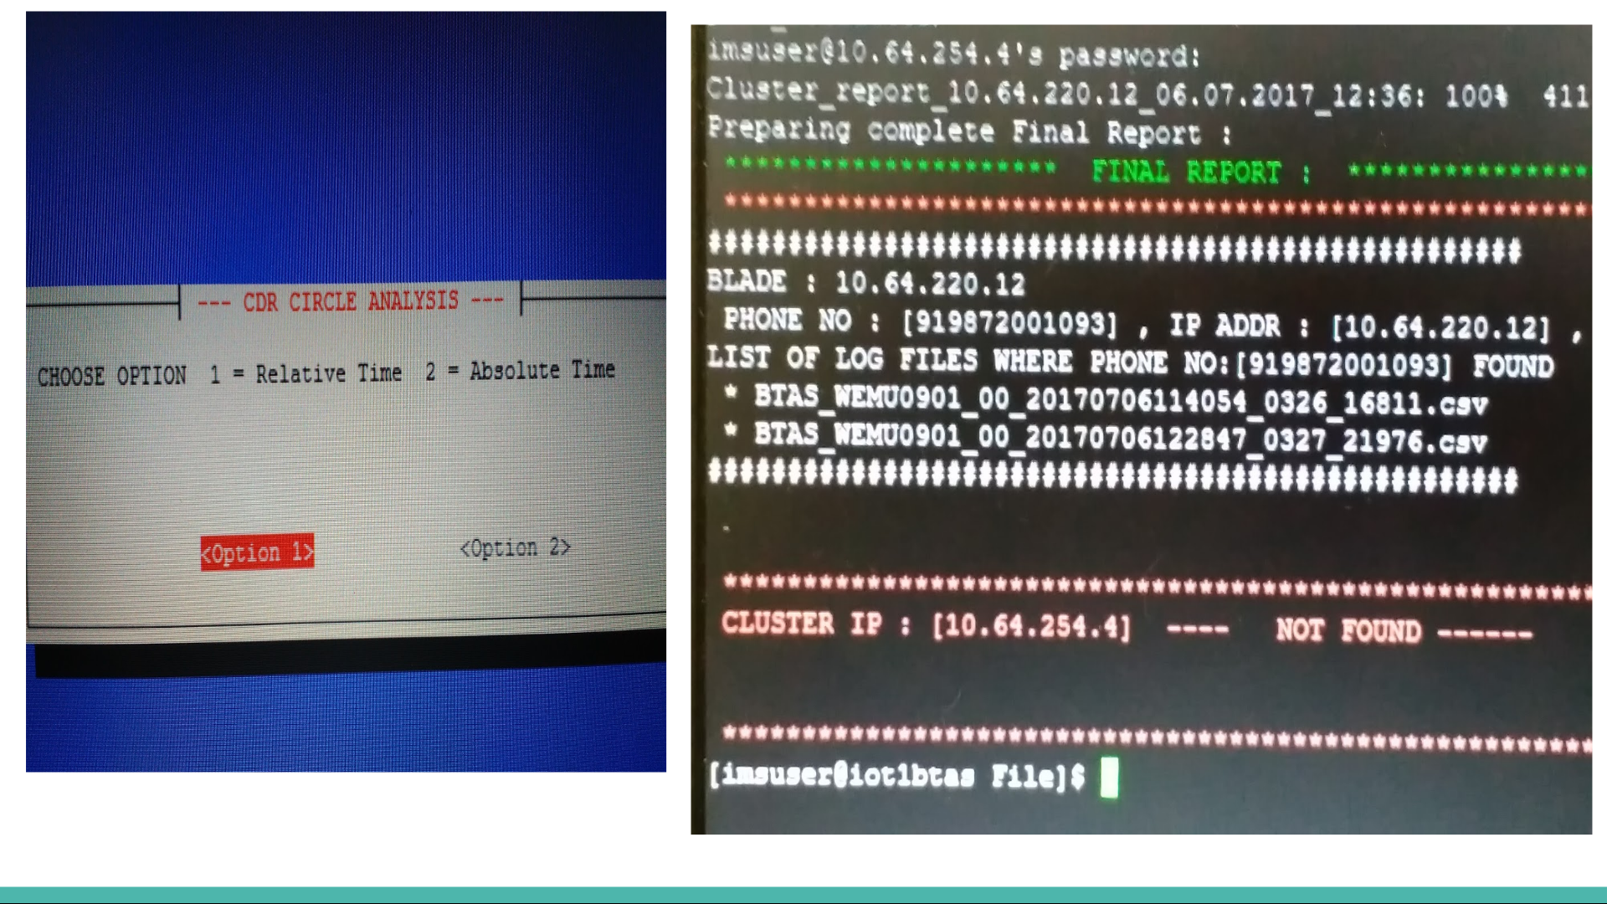

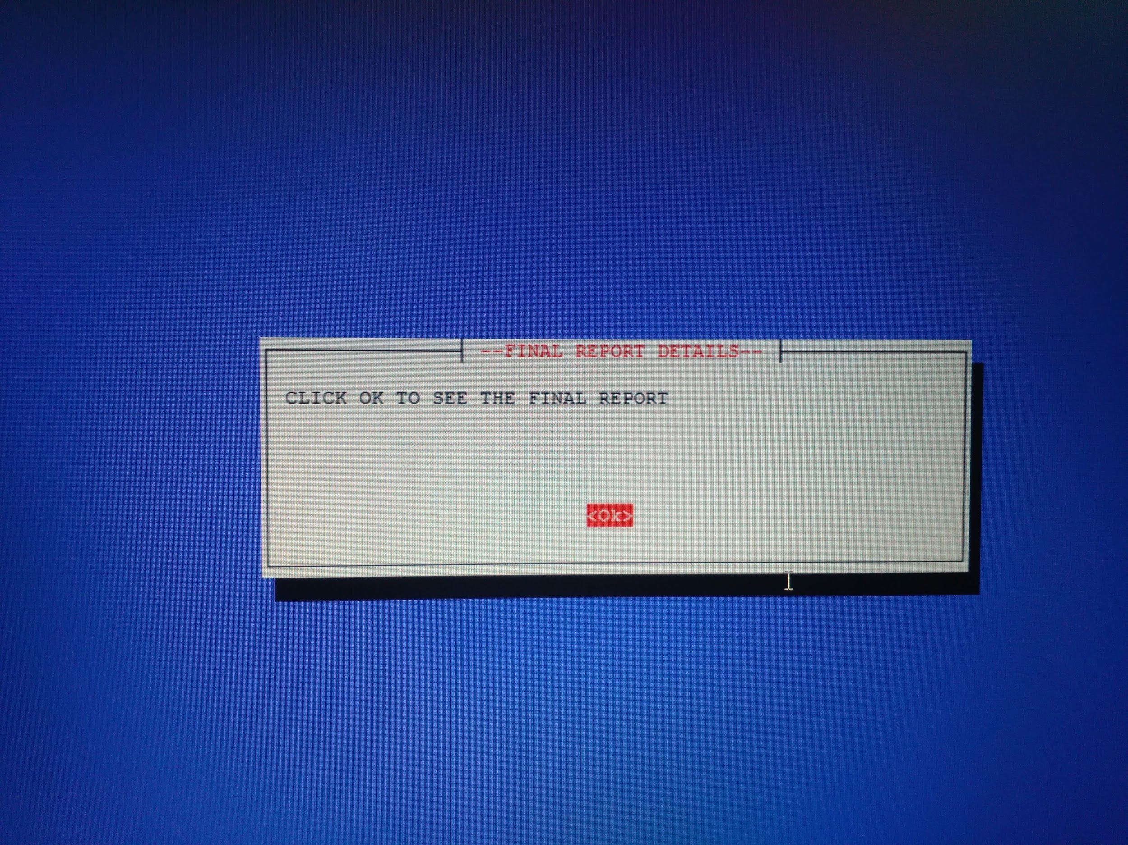

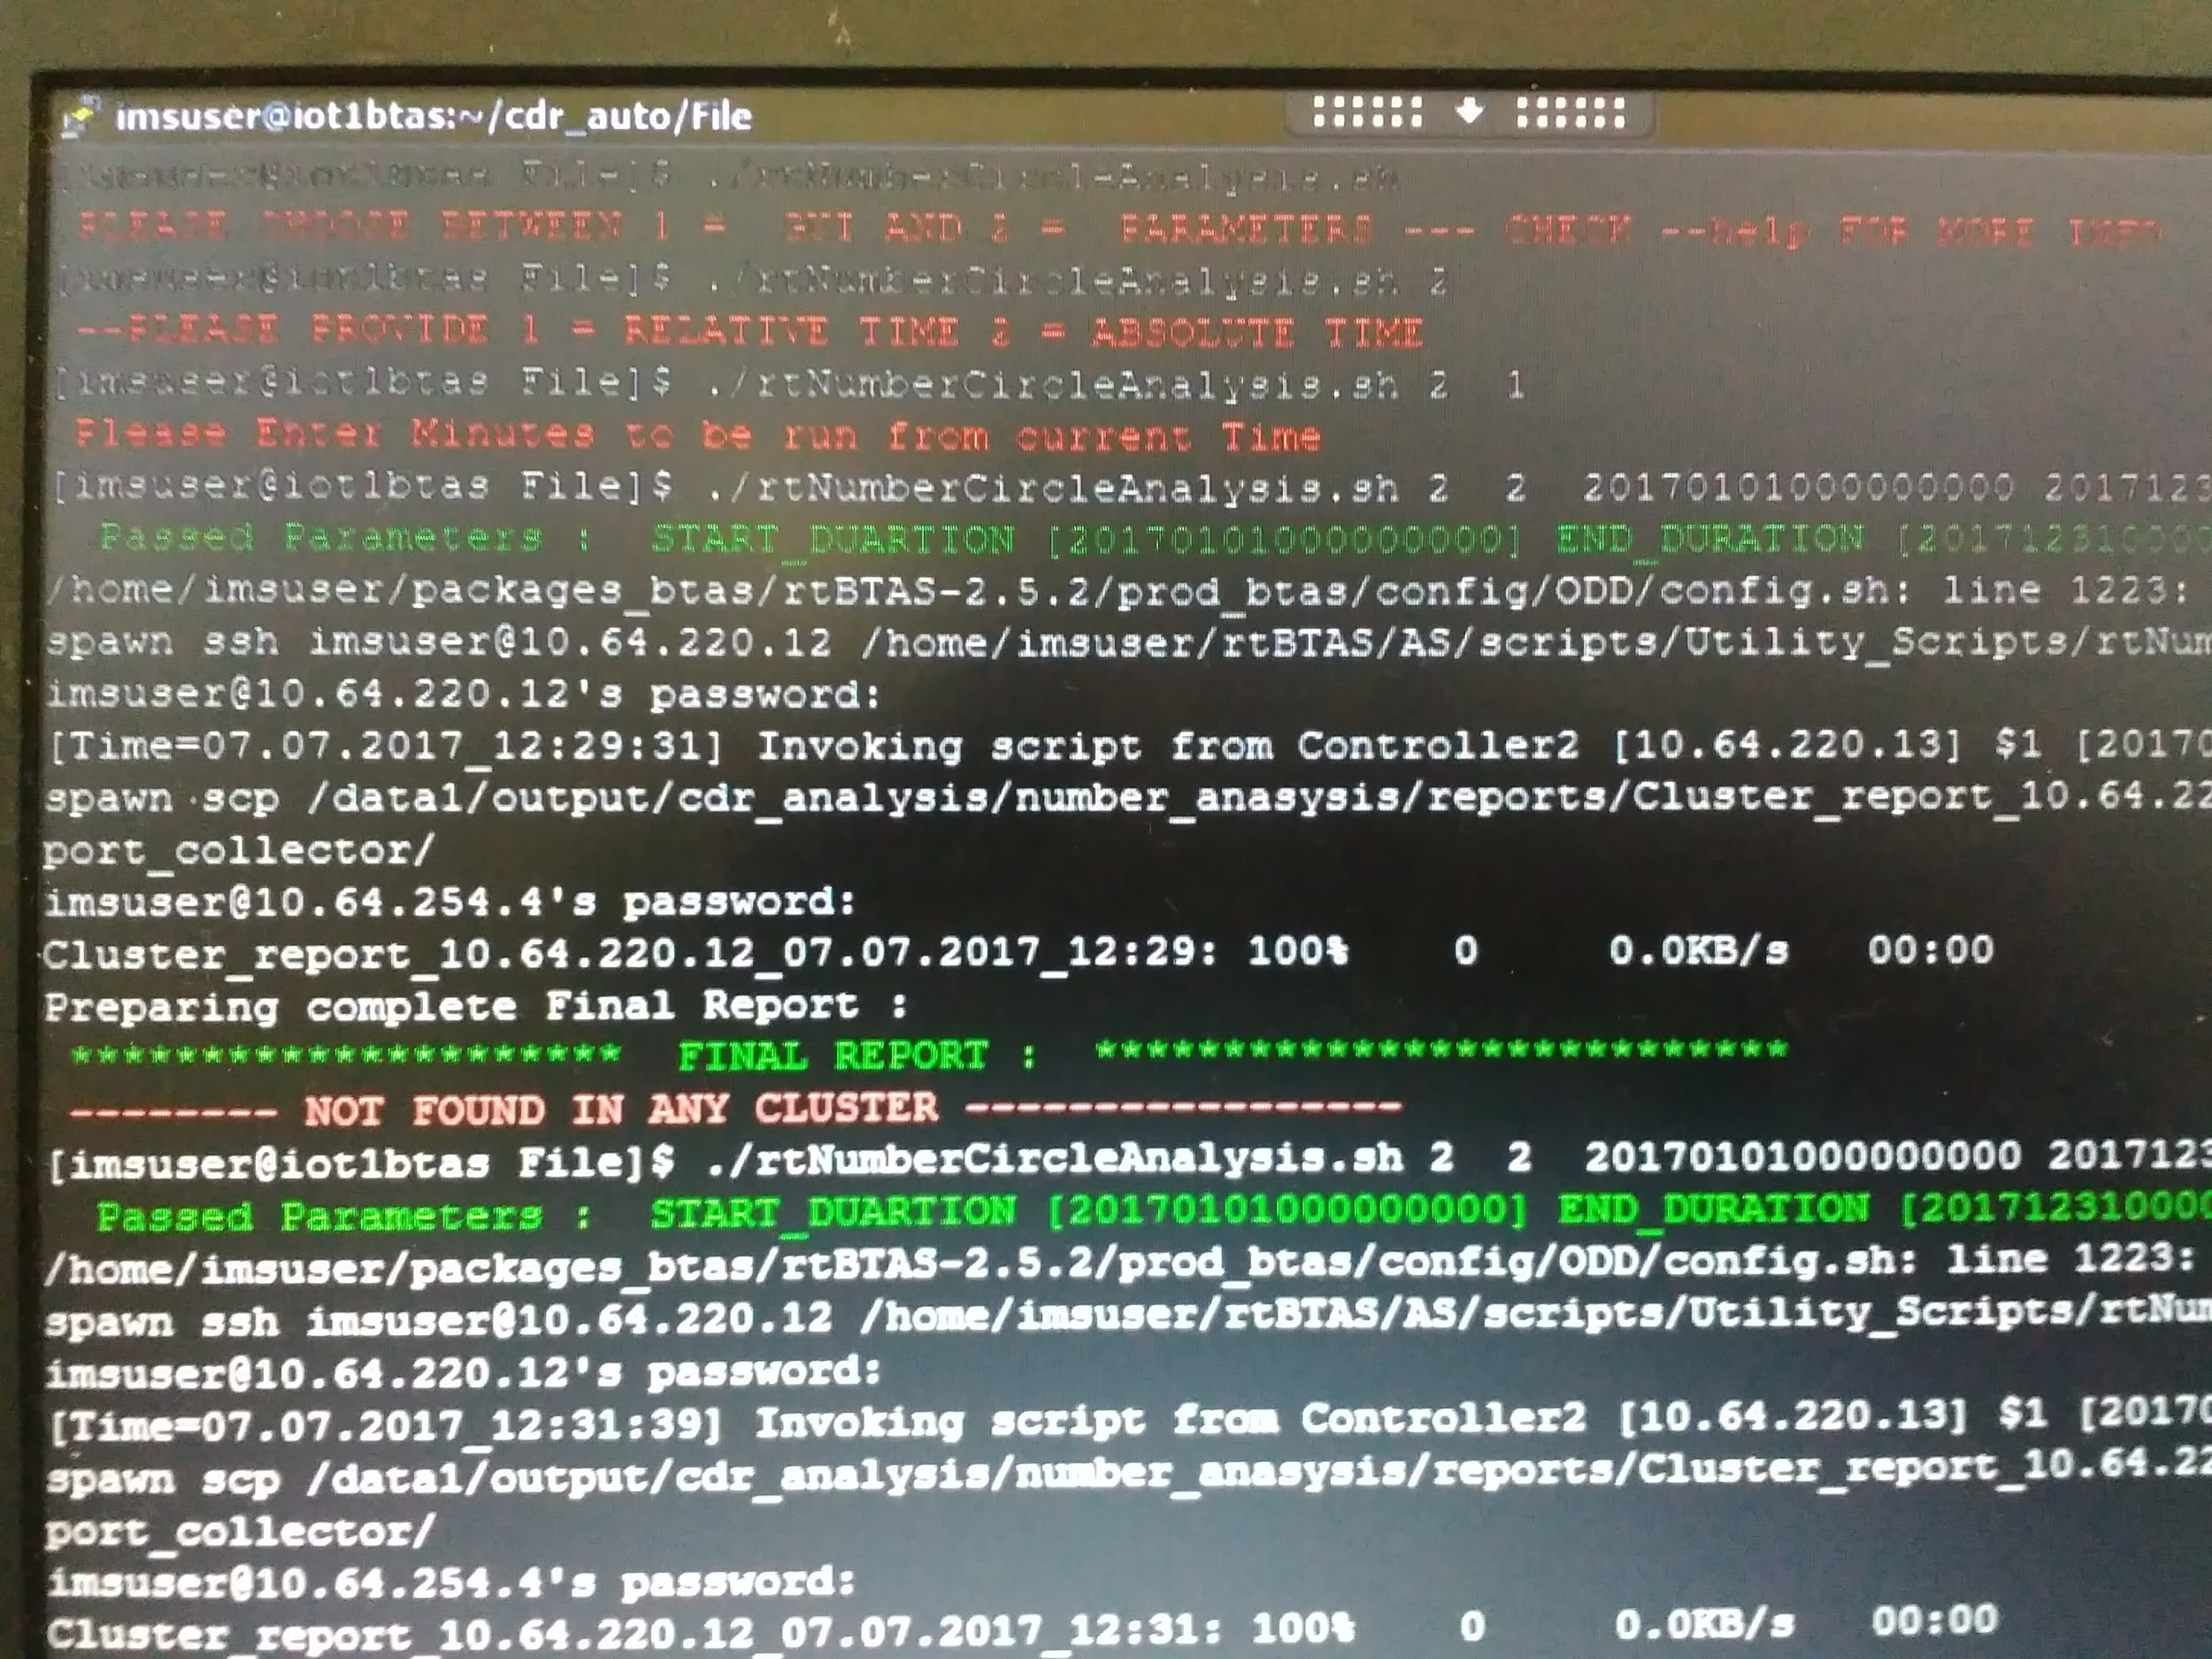

Passing the information asked in GUI .In figure final Report gives cluster wise information list all the csv file found in the cluster containing the phone number and between specified duration . If no blade of the cluster satisfy the constraints report displays NOT FOUND for the cluster.If not found in any cluster it displays NOT FOUND IN ANY CLUSTER .

Thus, now analyst can directly analyse the .csv file as cluster ip and file is known. Thus saving time and making process more efficient.

PART - 02

CDR SUCCESS RATE OF CALLS AND FAILURE ERROR CODES ANALYSIS

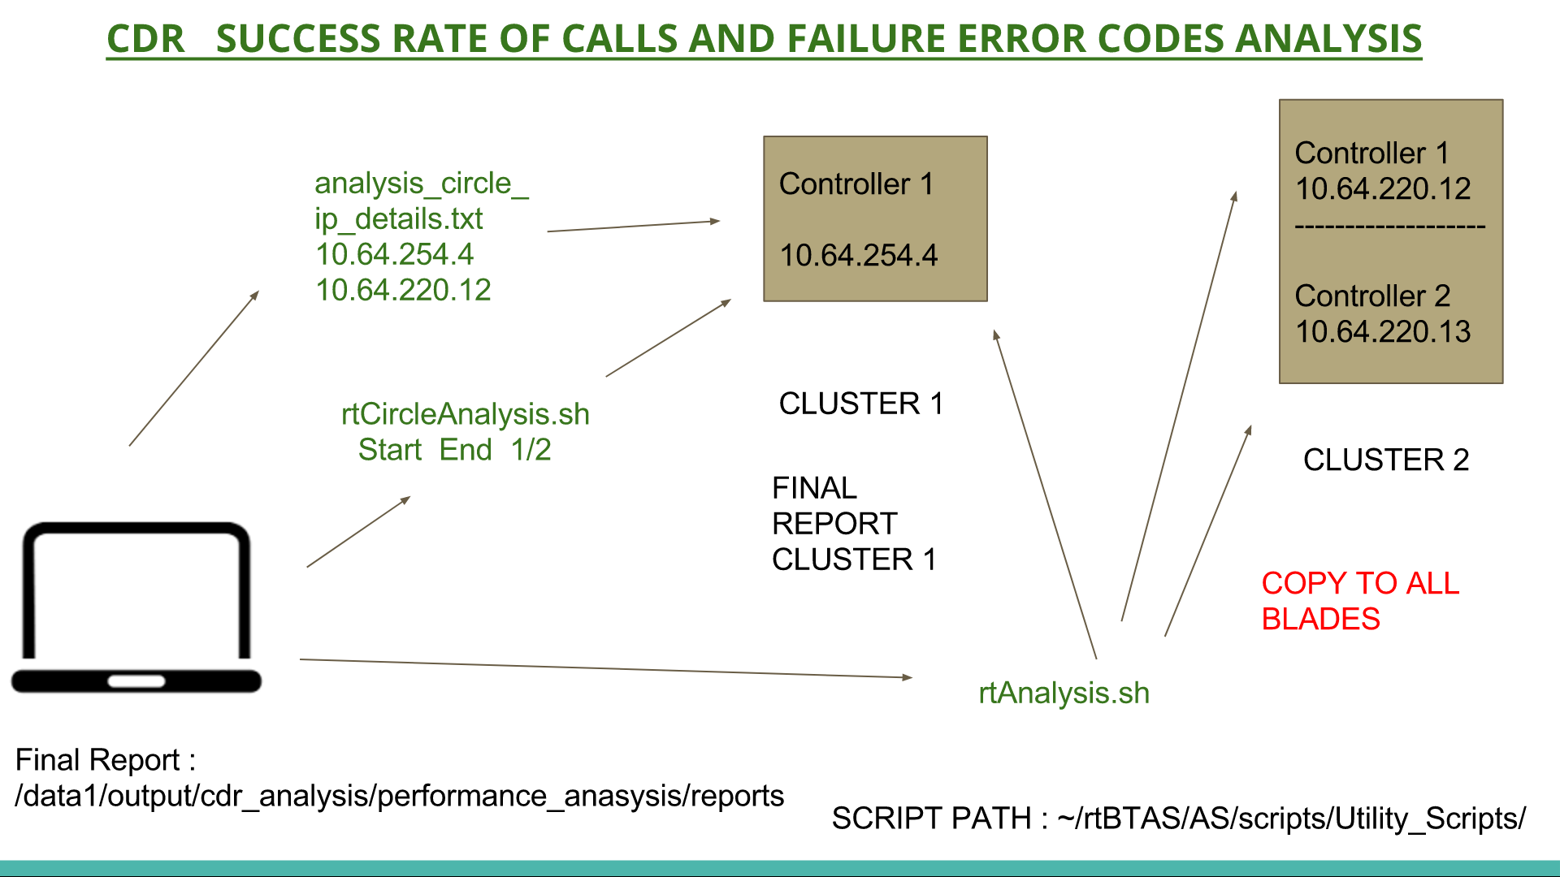

In the similar way with some logic changes we could easily find the success rate of calls in each blade and overall also study the error codes for call failure .

Success of Call depends on CALL_ANSWER_STATUS parameter(Field Number -12) of CDR.

CALL_ANSWERED_STATUS = 1 CALL ANSWERED SUCCESS

CALL_ANSWERED_STATUS = 2 CALL NOT ANSWERED FAILURE

Failure Code is extracted from Clear Code which is 10-digit code .

In analysis we display what all error codes internal and external occurred and how many times it occurred .

ANALYST EXECUTION :

1. Analyst has to copy the rtAnalysis.sh script to all 3 blades.

This will be done one time before executing.

2. Analyst will write the active controller ip of the all clusters where the

Script has to be invoked in the analysis_circle_ip_details.txt.

3. Analyst will execute the rtCircleAnalysis.sh script in the controller

Where final report containing the result from all cluster will be shown.

4. Also there is an Autocomplete Custom Tab Completion Feature on tab

Press during the invoking of Script it provides hints for further arguments

to be supplied . Inorder to enable the custom tab completion copy the

rtBashrc.sh script to ~/.bashrc and source ~/.bashrc.

Parameters to be supplied as command line argument to invoke the script are :

1. GUI-ARGUMENT CHOICE : Enter 1 = GUI 2 = Argument

-- SELECTED 1 REDIRECT TO GUI / SELECTED 2 ENTER FURTHER

PARAMETERS --

2. RELATIVE-ABSOLUTE CHOICE : Enter 1 = Relative Time 2 = Absolute Time

-- SELECTED 1 ENTER BELOW PARAMETER --

3. MINUTES : Minutes to be Run from current time

4. OPTION SUCESS_FAILURE : Enter 1 = SUCCESS_RATE 2 =   
 FAILURE_ERROR_CODE_ANALYSIS

-- SELECTED 2 ENTER BELOW PARAMETER --

3. START_DURATION : Start time from where you want start analysis

[YYYYMMDDHHMMSSMMM]

4. END_DURATION : End time where to stop analysis [YYYYMMDDHHMMSSMMM]

5. OPTION SUCESS_FAILURE : Enter 1 = SUCCESS_RATE

2 = FAILURE_ERROR_CODE_ANALYSIS

NOTE :

1. The rtAnalysis.sh Script should be copied to all blades in

/home/imsuser/rtBTAS/AS/scripts/Utility_Scripts/

Path.

2. The analysis_circle_ip_details.txt should be kept in the active

controller blade of the cluster where you will be executing the

rtCircleAnalysis.sh Script in the same path as

rtAnalysis.sh .

3. The rtCircleAnalysis.sh Script can be executed from any

Path.

WORKING OF SCRIPT :

Analyst invokes the rtCircleAnalysis.sh with arguments which after checks fetches active controller ip_addr from analysis_circle_ip_details.txt and invokes rtAnalysis.sh on these ip_addrress.The rtAnalysis.sh creates self report of cluster and triggers rtAnalysis.sh in all blades of the cluster.If blade running the rtAnalysis.sh is non controller then report is scp to controller and it is controller it creates final Cluster report which is scp to ip

Passed as argument.

The script generates a log file , report file and logs of script execution in each blade.

PATH :

Cluster_Report :

/data1/output/cdr_analysis/performance_anasysis/reports

Logs : /data1/output/cdr_analysis/performance_anasysis/logs

Log_script : /tmp/

In cluster where rtCircleAnalysis is running it waits for 10 sec for all Cluster reports and then creates final report of all cluster which is displayed just after execution of script.

Final Report is stored in :

/data1/output/cdr_analysis/performance_anasysis/reports/

Final Report is also copied and stored in :

/data1/output/cdr_analysis/performance_anasysis/collection_final_report

The cluster Reports received can be found in Path : /data1/output/cdr_analysis/performance_anasysis/circlewise_report_collect

or

Also to study script execution it generates log file in /tmp/ path with its timestamp.

RESULTS :

Help option is available for both rtNumberCircleAnalysis and rtCircleAnalysis Script.Both script can be invoked either by GUI or by passing arguments in command line and also autocomplete feature is available for both.

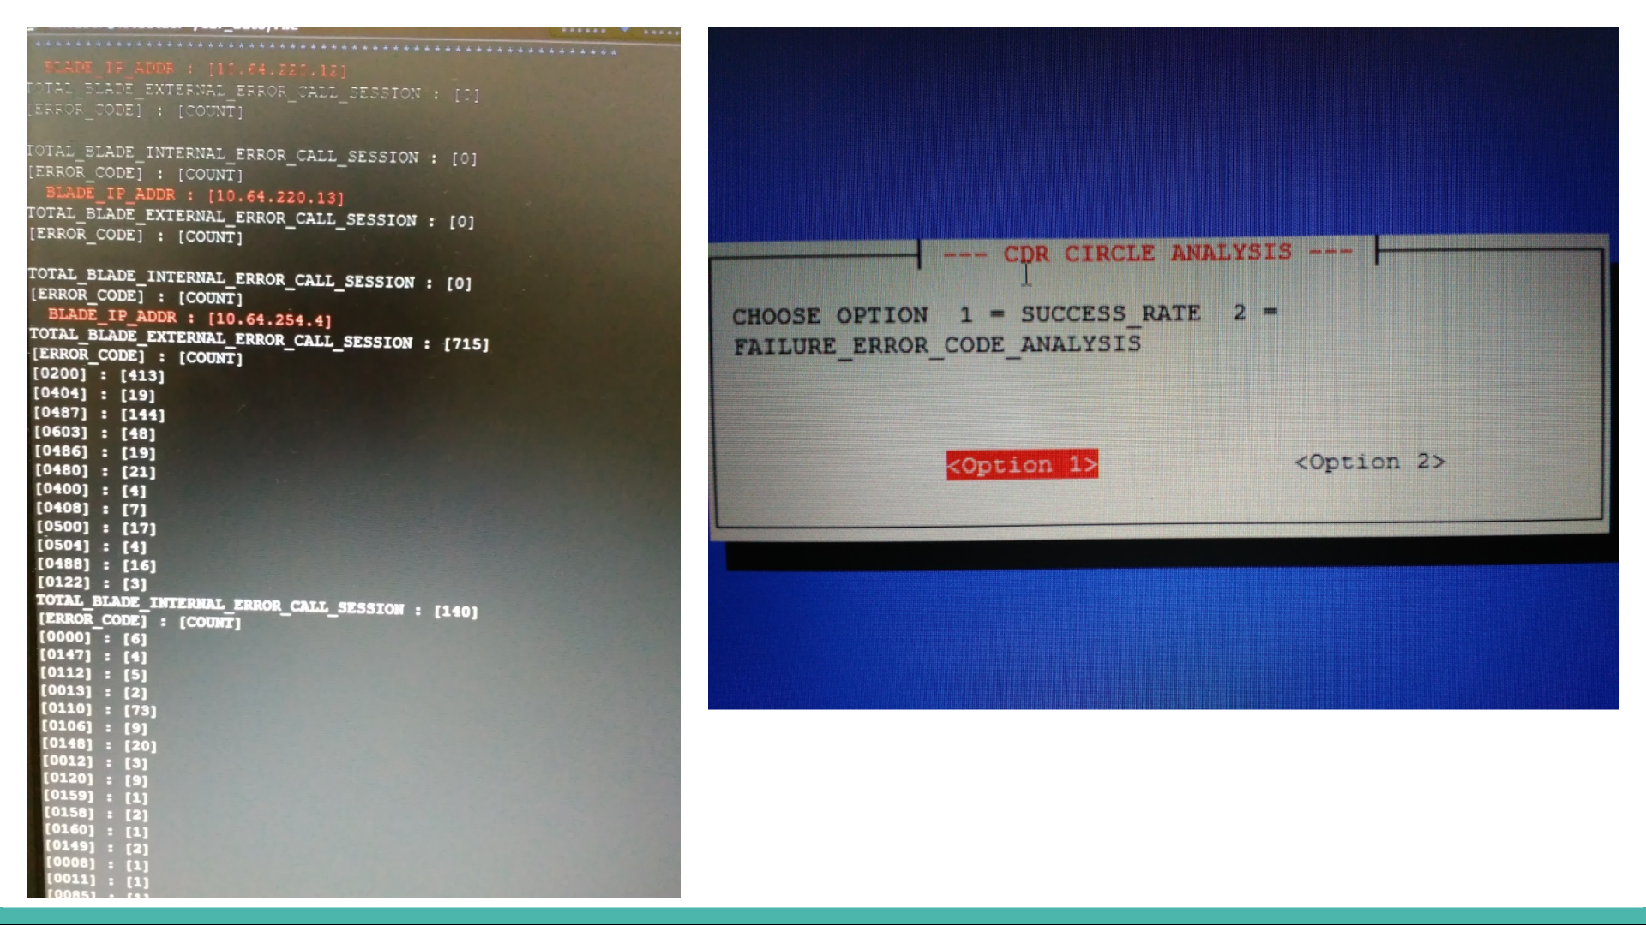

Error Codes with their count is shown in fig.Each error code has specific meaning and also it is important whether it is external or internal.

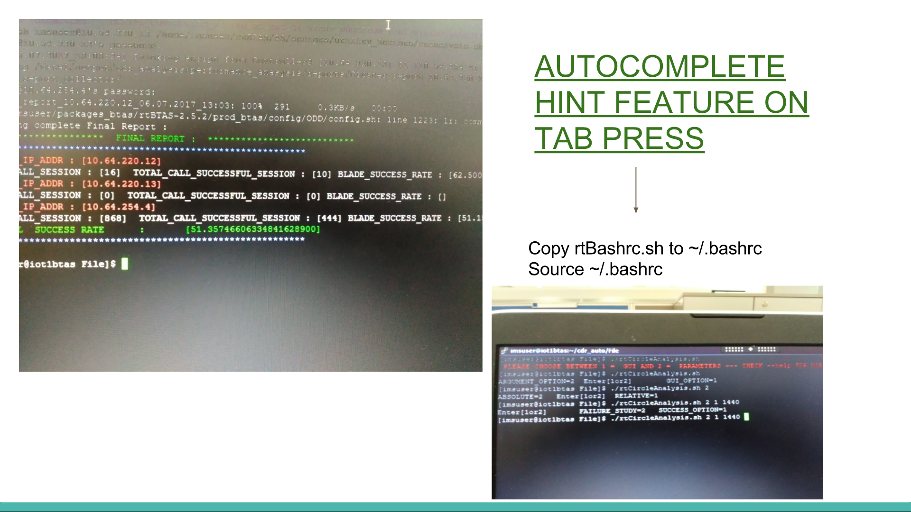

Success Rate for each blade and overall success_rate .During implementation I observed that if there are 5670 call session occurred in a blade out of them only 2678 were successful that is 53.56% of success.

JIO is trying level best to make to 100%.

Autocomplete feature makes it easy and more user - friendly. During implementation it build id GUI in java but java swing utility was not installed GUI is build using dialog interface of linux.Implementation of Autocomplete Feature was good experience I first I was giving up as it was usually done using yang compiler which is very complex but I did it using compgen and complete_script concept where all words entered are stored in COMP_WORDS array whose index is determined by COMP_CWORDS.

ADVANTAGES :

1. Automation in a repetitive process made it time saving.
2. Manually checking was replaced by tool making it fast and efficient.
3. Earlier it required 3-4 days to study all files and usually most time there was same error that occurred earlier required same time to catch it. Now drastically saving time and making analysis super - easy.
4. It is user - friendly .Anybody without knowledge of Script can execute it easily.

LIMITATIONS and EXTENSIONS :

1. Works well upto 100,00 call sessions per blade.It is tested upto 2 cluster of Single blade , dual blade .It can made more efficient by using efficient data structures.
2. Phone No. grep is single can extended to A-party and B-party Number more parameters of CDR can be analysed so that analyst need not check the csv file filtered.

PROJECT - 02



UNDERSTANDING FUNCTIONALITY OF

WEBRTC SOCKET.IO & SIP

WEBRTC - Web Real Time Communication

SIP - Session Initiation Protocol

Socket.io - Javascript Library for realtime web communication

PART - 01

INTRODUCTION TO WEBRTC :

WebRTC is an open source project to enable realtime communication of audio, video and data in Web and native apps.

WebRTC has several JavaScript APIs.

* [getUserMedia()](https://webrtc.github.io/samples/src/content/getusermedia/gum/): capture audio and video.
* [MediaRecorder](https://webrtc.github.io/samples/src/content/getusermedia/record/): record audio and video.
* [RTCPeerConnection](https://webrtc.github.io/samples/src/content/peerconnection/pc1/): stream audio and video between users.
* [RTCDataChannel](https://webrtc.github.io/samples/src/content/datachannel/basic/): stream data between users.

***WebRTC still needs servers:***

* ***For clients to exchange metadata to coordinate communication: this is called signaling.***
* ***To cope with network address translators (NATs) and firewalls.***

In order for a WebRTC application to set up a 'call', its clients need to exchange information:

* Session control messages used to open or close communication.
* Error messages.
* Media metadata such as codecs and codec settings, bandwidth and media types.
* Key data, used to establish secure connections.
* Network data, such as a host's IP address and port as seen by the outside world.

This signaling process needs a way for clients to pass messages back and forth. That mechanism is not implemented by the WebRTC APIs . I used the node and Web Server of Chrome app to understand WebRTC.

For signalling I used JSEP - [JavaScript Session Establishment Protocol](http://tools.ietf.org/html/draft-ietf-rtcweb-jsep-03#section-1.1)

Which exchanges information in form of SDP - Session Description Protocol similar to SIP - Session Initiation Protocol.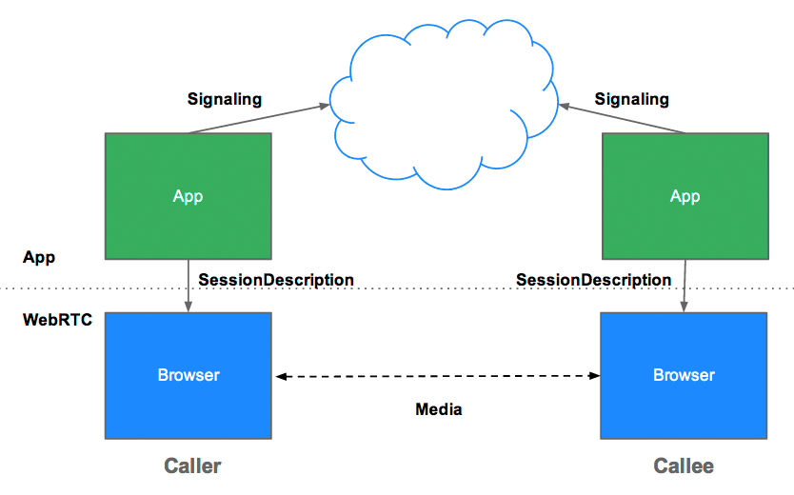

***JSEP architecture***

JSEP requires the exchange between peers of offer and answer.

IMAGINE ALICE TRYING CALL EVE

1. Alice creates an RTCPeerConnection object.
2. Alice creates an **offer** (an SDP session description) with the RTCPeerConnection *createOffer()* method.
3. Alice calls *setLocalDescription()* with his offer.
4. Alice stringifies the offer and uses a signaling mechanism to send it to Eve.
5. Eve calls *setRemoteDescription()* with Alice's offer, so that her RTCPeerConnection knows about Alice's setup.
6. Eve calls *createAnswer()*, and the success callback for this is passed a local session description: Eve's **answer**.
7. Eve sets her answer as the local description by calling *setLocalDescription()*.
8. Eve then uses the signaling mechanism to send her stringified answer back to Alice.
9. Alice sets Eve's answer as the remote session description using *setRemoteDescription()*.

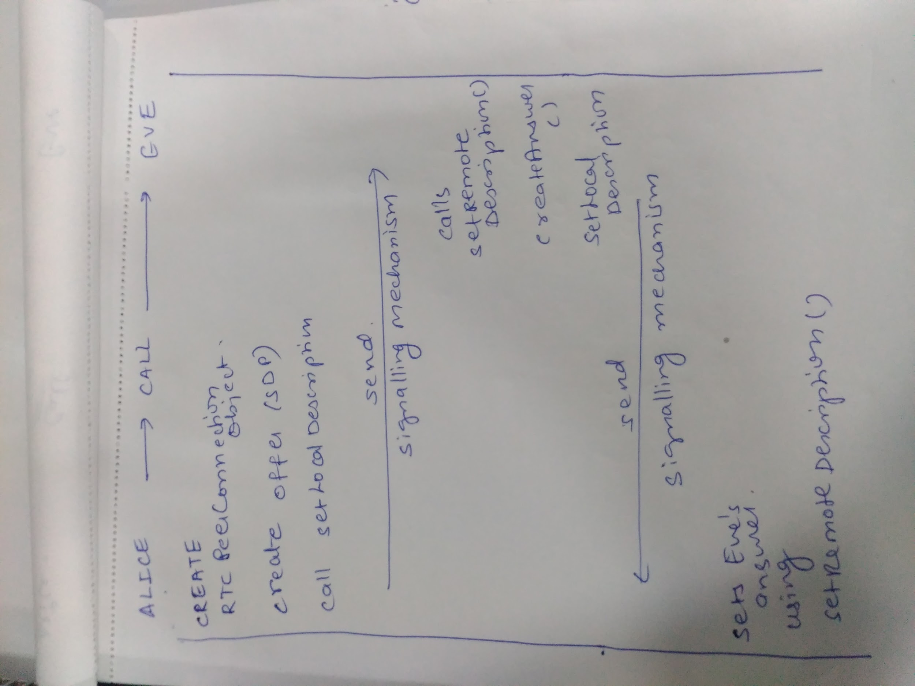

Alice and Eve also need to exchange network information. The expression 'finding candidates' refers to the process of finding network interfaces and ports using the [ICE framework](http://en.wikipedia.org/wiki/Interactive_Connectivity_Establishment).

1. Alice creates an RTCPeerConnection object with an *onicecandidate* handler.
2. The handler is called when network candidates become available.
3. In the handler, Alice sends stringified candidate data to Eve, via their signaling channel.
4. When Eve gets a candidate message from Alice, she calls *addIceCandidate()*, to add the candidate to the remote peer description.

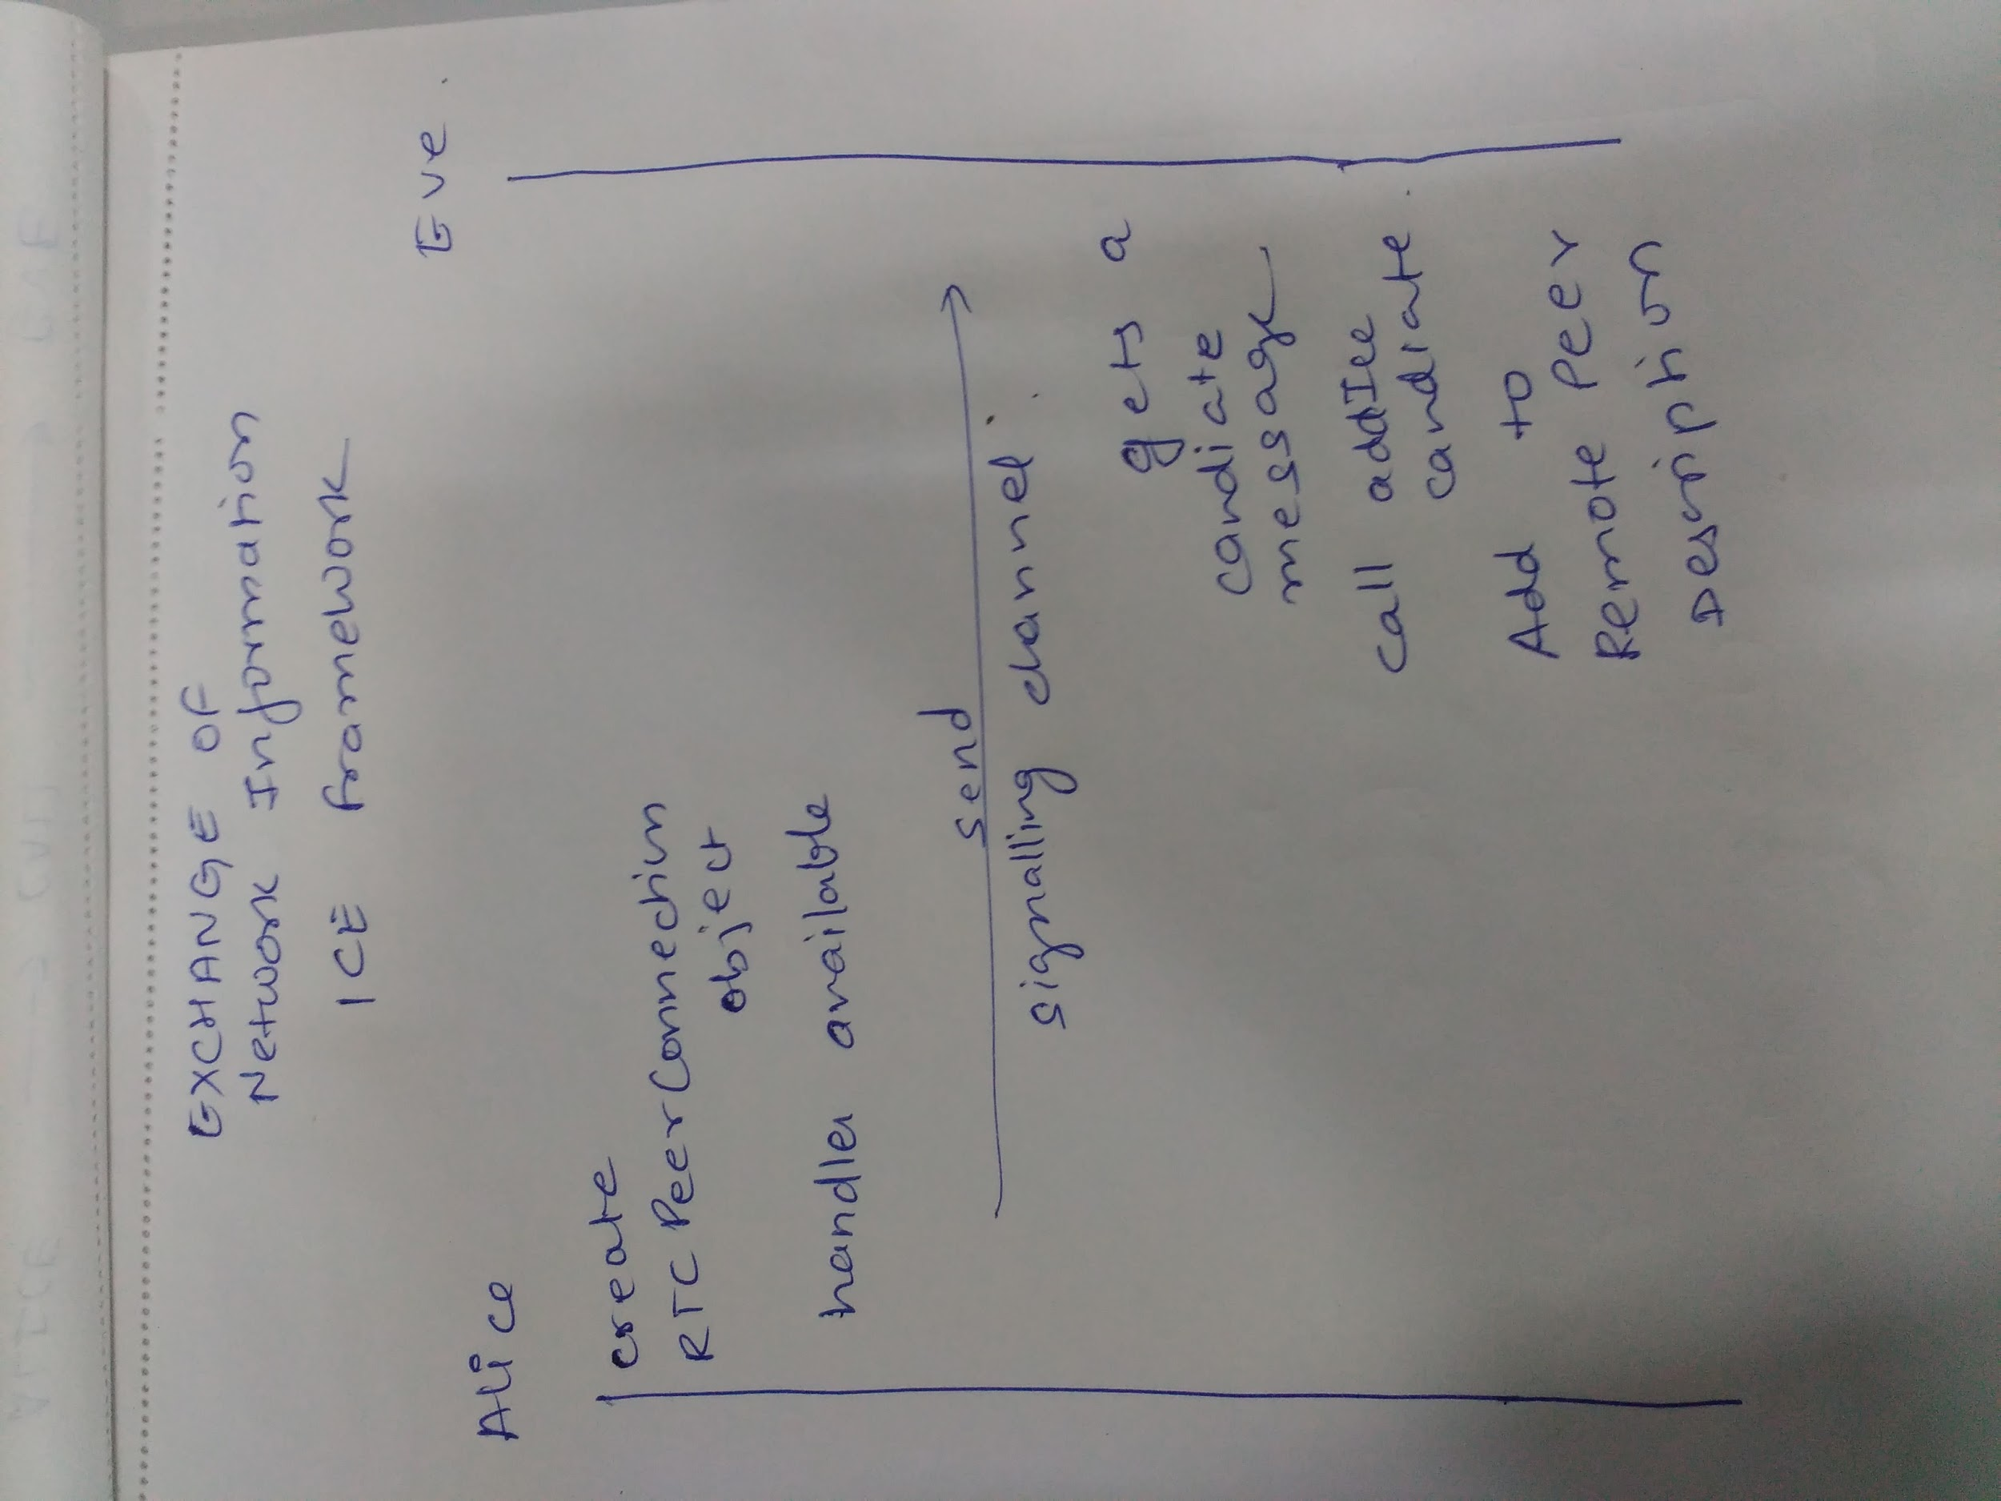

RESULTS :

Using WebRTC I build a webpage to understanding working of WebRTC using JSEP . On Click of Start Button using getUserMedia self video is captured which is streamed to other video element by exchanging metadata . On clicking HangUp option streaming video connection gets closed.

Video Calling Using WebRTC :

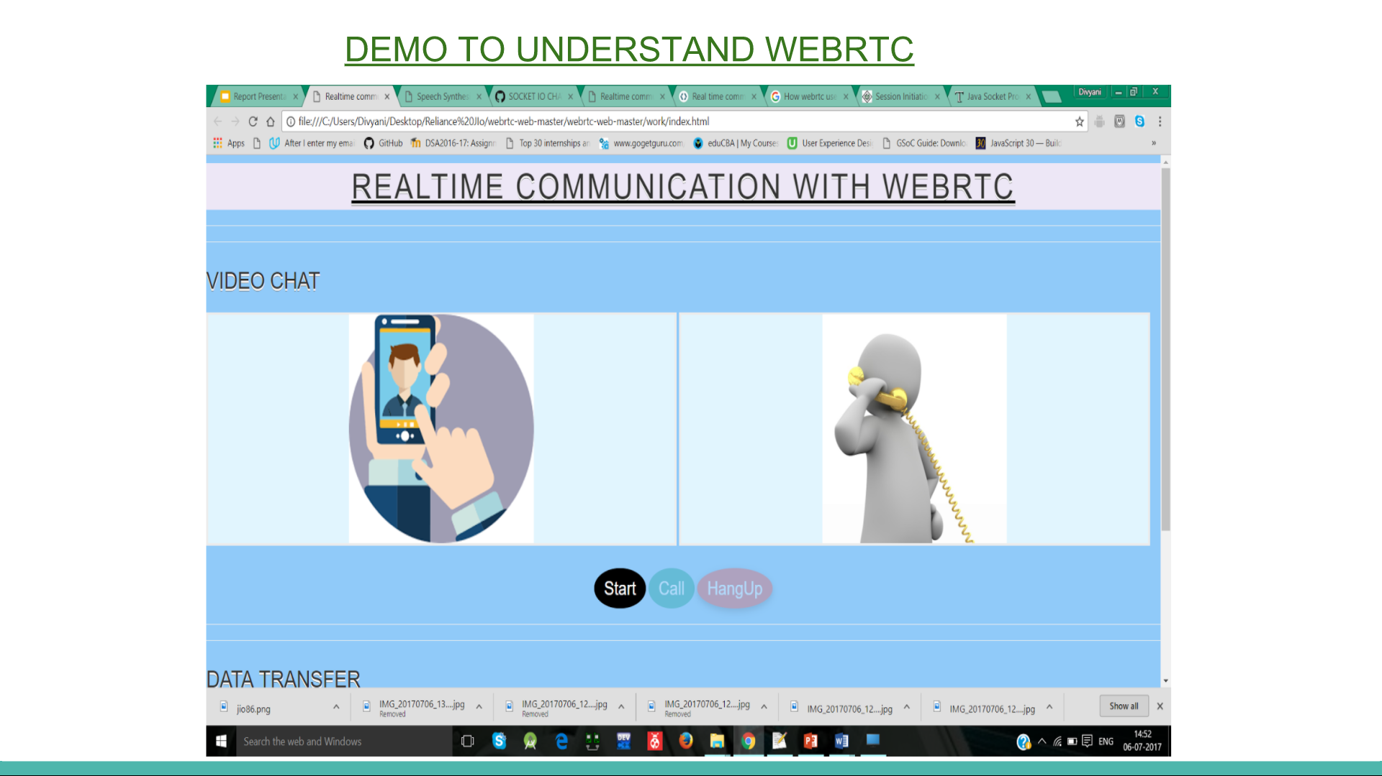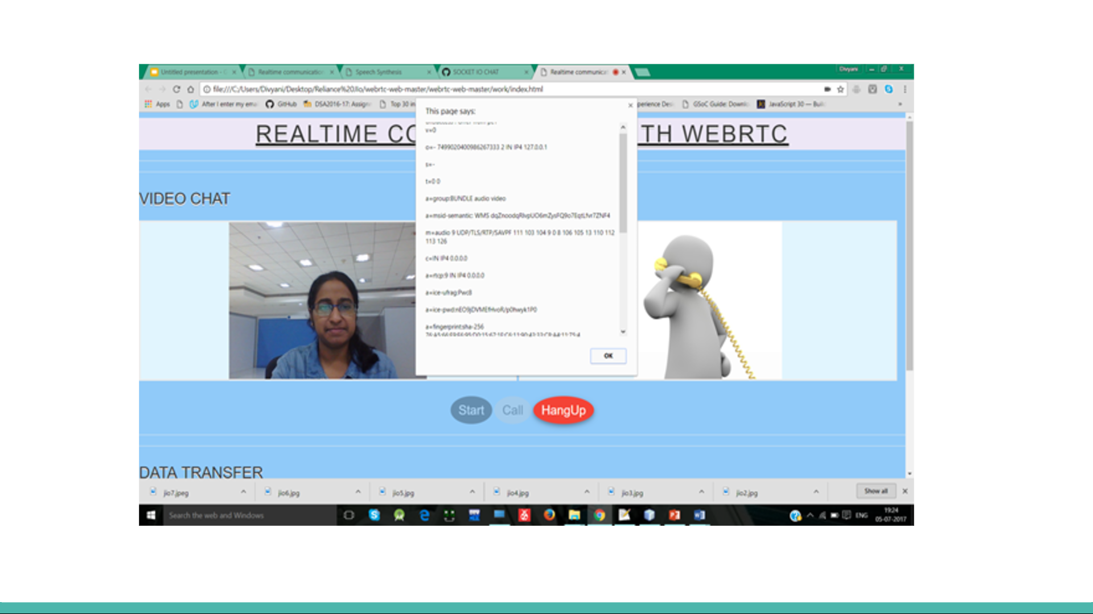

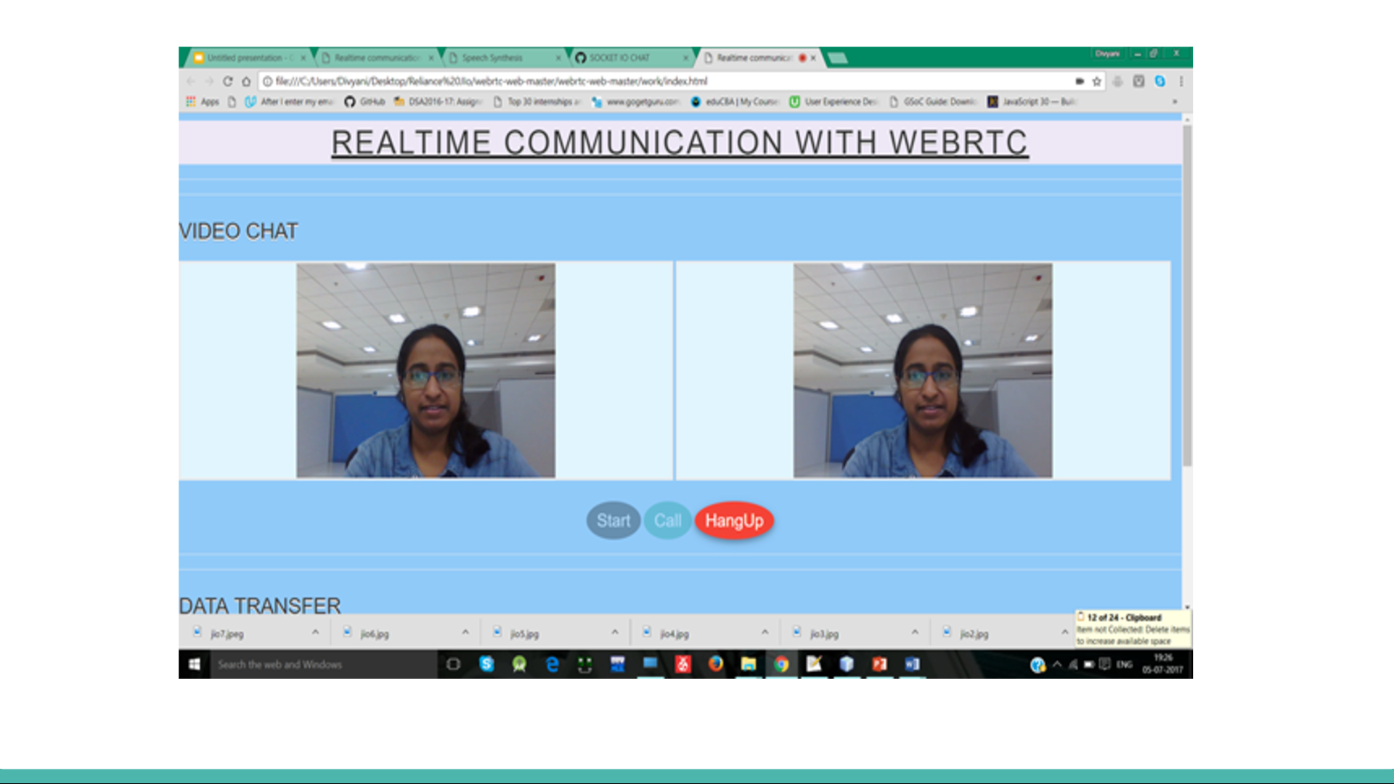

Data Transfer Using WebRTC - RTC Data Channel

On Clicking Start Button Creates connection and sender’s textArea is enabled.On Clicking send Button the data is transferred to other section using RTCDataChannel (signalling channel) .And Clear Button disables both the textAreas.

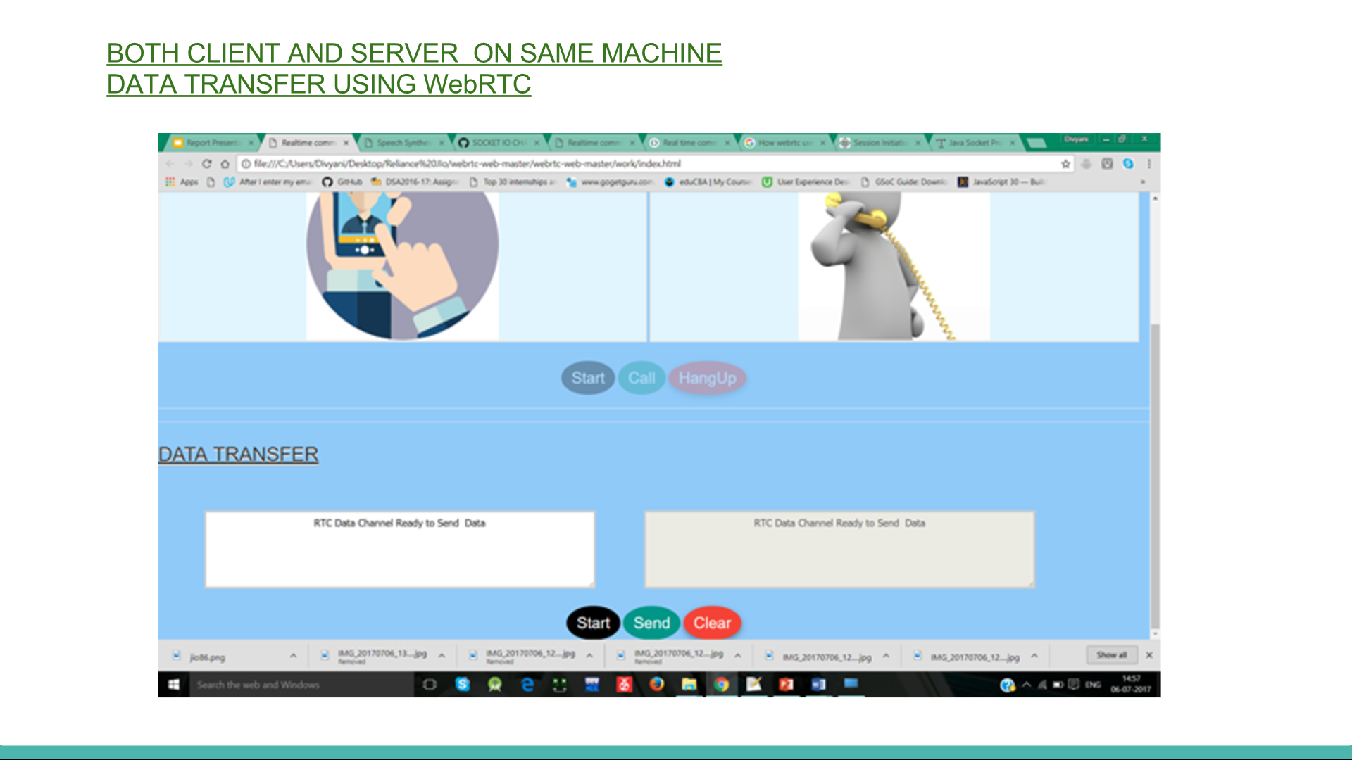

Below is the Offer and Answer Exchange in SDP Format :

Demo Within same PC so IPv4 is same

YourId

{"type":"answer","sdp":"v=0\r\no=- 8542806470704944223 2 IN IP4 127.0.0.1\r\ns=-\r\nt=0 0\r\na=group:BUNDLE data\r\na=msid-semantic: WMS\r\nm=application 59835 DTLS/SCTP 5000\r\nc=IN IP4 10.47.3.38\r\nb=AS:30\r\na=candidate:3442427457 1 udp 2113937151 10.47.3.38 59835 typ host generation 0 network-cost 50\r\na=ice-ufrag:EayA\r\na=ice-pwd:msvsSmCqCZAOOxfWGzO4tDij\r\na=fingerprint:sha-256 F0:98:88:5A:33:6F:54:1B:D9:97:A0:FA:16:90:FE:66:EF:37:98:0B:AF:C9:EA:7B:7F:2D:26:59:71:82:7F:82\r\na=setup:active\r\na=mid:data\r\na=sctpmap:5000 webrtc-datachannel 1024\r\n"}

Other Id

{"type":"offer","sdp":"v=0\r\no=- 582049794477629011 2 IN IP4 127.0.0.1\r\ns=-\r\nt=0 0\r\na=group:BUNDLE data\r\na=msid-semantic: WMS\r\nm=application 60116 DTLS/SCTP 5000\r\nc=IN IP4 116.50.70.78\r\na=candidate:3442427457 1 udp 2113937151 10.47.3.38 60116 typ host generation 0 network-cost 50\r\na=candidate:842163049 1 udp 1677729535 116.50.70.78 60116 typ srflx raddr 10.47.3.38 rport 60116 generation 0 network-cost 50\r\na=ice-ufrag:PWda\r\na=ice-pwd:pL1zKhneVzC1FC1F8K/Z5mps\r\na=fingerprint:sha-256 82:5D:67:4F:E3:52:54:3F:40:F5:18:E4:F5:F6:6C:35:BD:39:45:FE:7D:0B:F5:C6:1A:8B:A4:C4:1E:2D:92:7B\r\na=setup:actpass\r\na=mid:data\r\na=sctpmap:5000 webrtc-datachannel 1024\r\n"}

PART -02

INTRODUCTION TO SOCKET.IO

**Socket.IO** is a [JavaScript](https://en.wikipedia.org/wiki/JavaScript) library for realtime [web applications](https://en.wikipedia.org/wiki/Web_application). It enables realtime, bi-directional communication between web clients and servers. It has two parts: a [client-side](https://en.wikipedia.org/wiki/Client-side) library that runs in the [browser](https://en.wikipedia.org/wiki/Web_browser), and a [server-side](https://en.wikipedia.org/wiki/Server-side) library for [Node.js](https://en.wikipedia.org/wiki/Node.js)

*Socket.IO enables real-time bidirectional event-based communication.*

*This means that the server can push messages to clients.*

*Whenever you write a chat message, the idea is that the server will get it and push it to all other connected clients.*

*It works on every platform, browser or device, focusing equally on reliability and speed.*

*Socket.IO is used in real time analytics , instant messaging , document collaboration and in binary streaming.*

RESULTS :

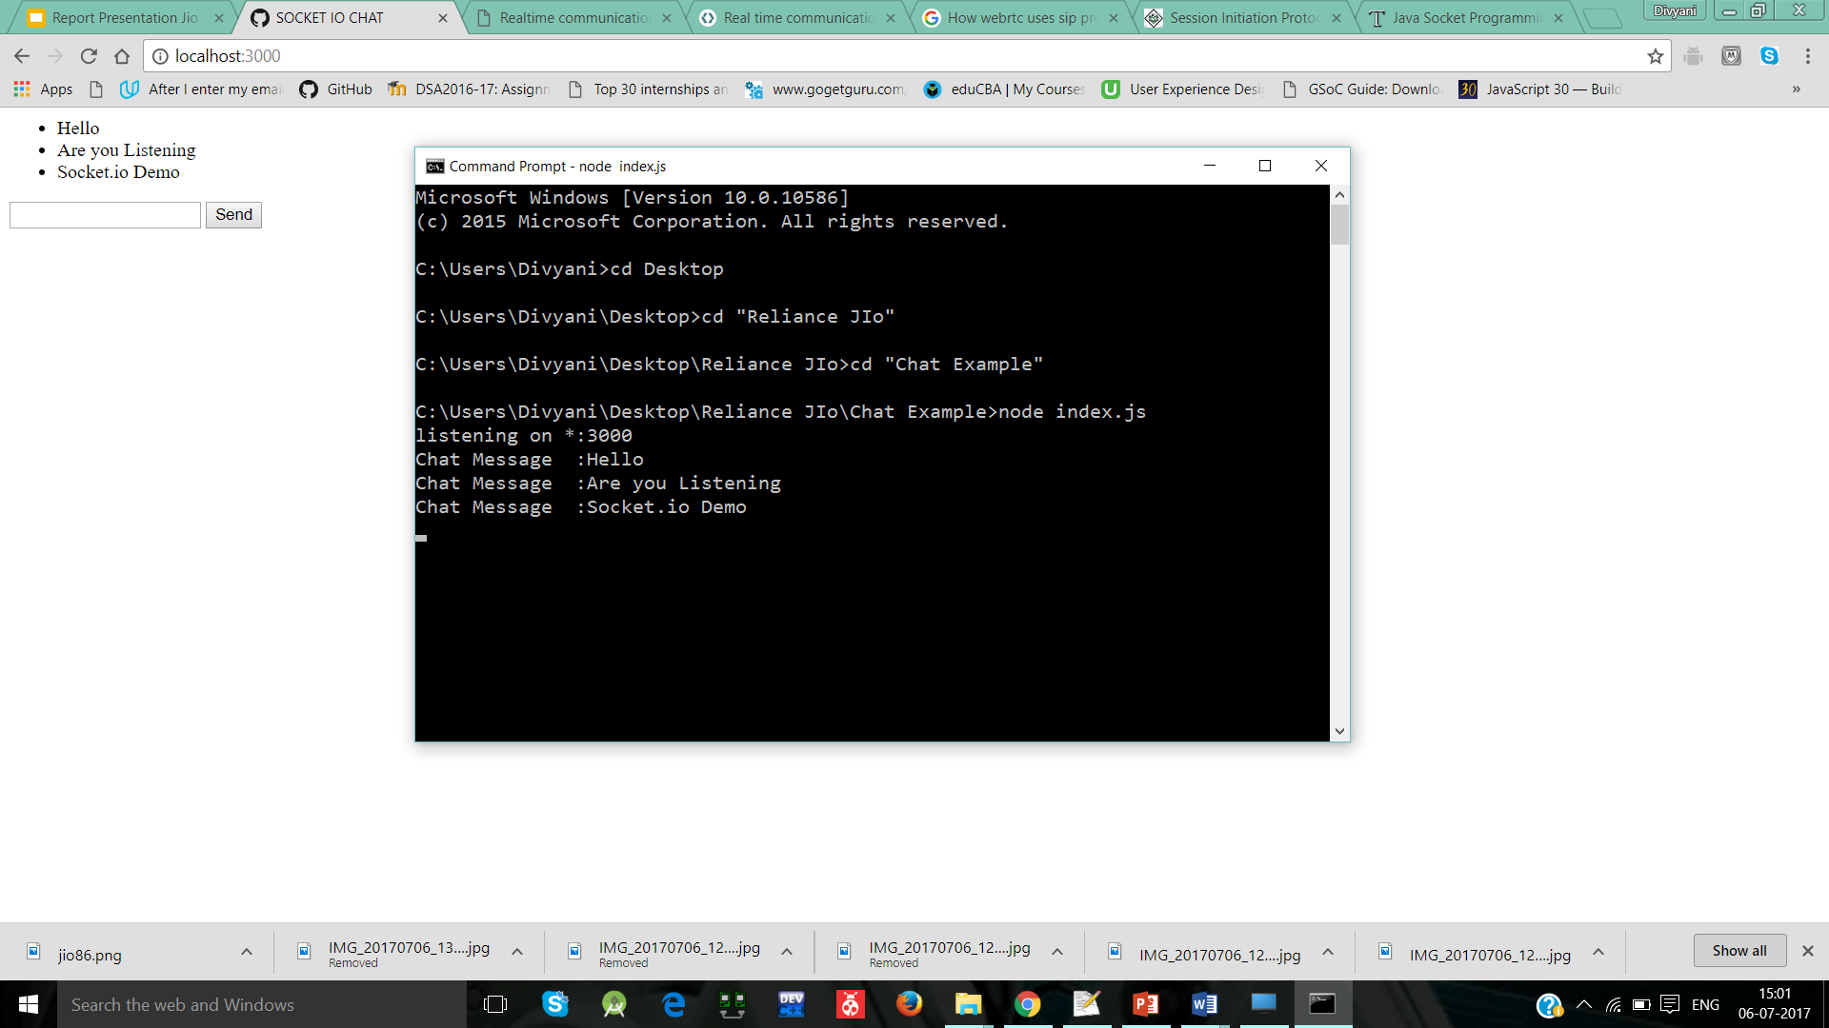

Using socket.io concept and node this was simple demo to understand socket.io . The text written in input Field is transferred in runtime to node console .

I also tried to implement socket in Java

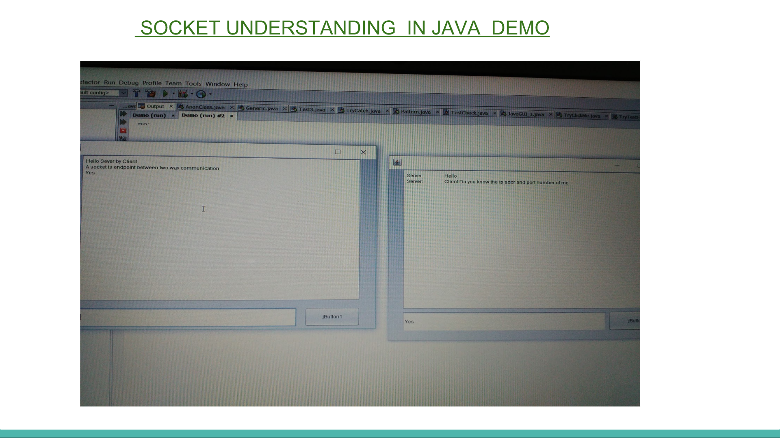

Using Java Swing I created two GUI one for client and other for server.Using Socket I opened connection between client and server and using DataInputStream enabling the data transfer between client and server.

Even it was to fun to learn about SIP Protocol .

PART - 03

INTRODUCTION TO SIP :

**Session Initiation Protocol** (**SIP**) is a signaling **protocol** used for initiating, maintaining, modifying and terminating real-time **sessions** that involve video, voice, messaging and other communications applications and services between two or more endpoints on IP networks.

I understood the basic Call Flow and headers of SIP Protocol , about SIP Network Elements , SIP Messages,SIP URI (sip:username@domain).

Study of SIP Protocol was interesting. I will try to briefly explain topics.

SIP Network Elements :

User Agents :

Internet end points that use SIP to find each other and to negotiate a session characteristics are called *user agents*.

User agents are logically divided into two parts:

**User Agent Client (UAC):** The entity that sends a request and receives a response.

**User Agent Server (UAS):**  The entity that receives a request and sends a response.

Each User Agent contains UAS and UAC . The part of the proxy that receives the INVITE from the caller in fact acts as a UAS. When forwarding the request statefully the proxy creates two UACs, each of them is responsible for one branch.

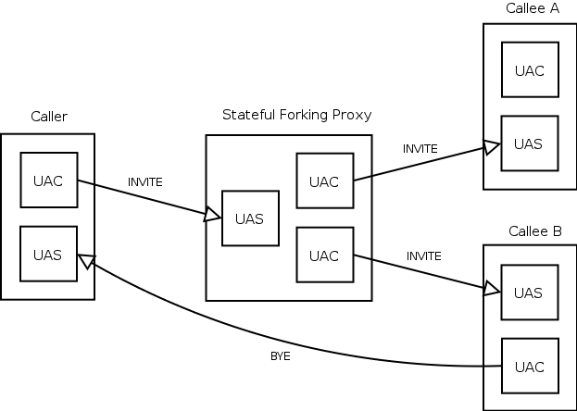

Proxy Server :

It is the network element that takes a request from a user agent and forwards it to another user. There are two types of proxy servers:

**Stateless Proxy Server**: It simply forwards the message received. This type of server does not store any information of a call or a transaction.

**Stateful Proxy Server:** This type of proxy server keeps track of every request and response received and can use it in future if required. It can retransmit the request, if there is no response from the other side in time.

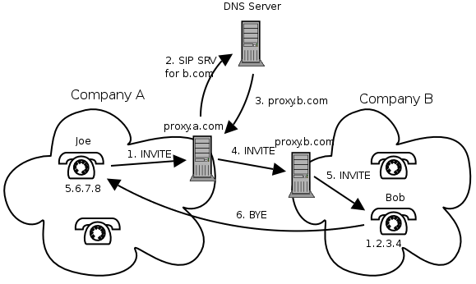

SIP Transactions and Headers :

A transaction is a sequence of SIP messages exchanged between SIP network elements. A transaction consists of one request and all responses to that request.

**HEADERS :**

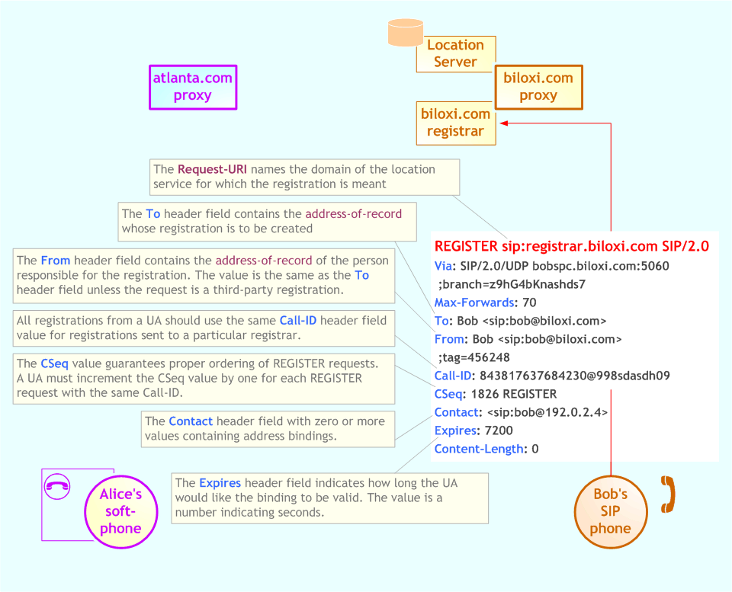

**SIP BASIC CALL FLOW :**

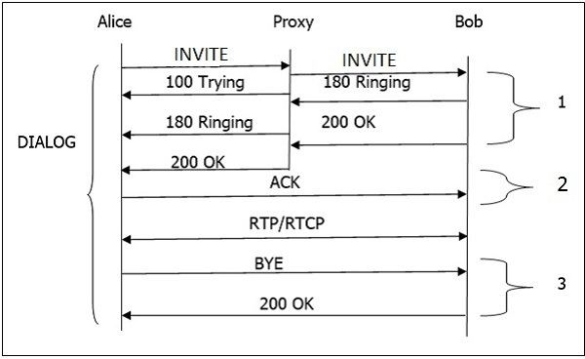

1. Alice send Invite (initiating a session) to Bob which is redirected by Proxy Server. Proxy Server then sends 100 Trying to Alice to stop sending further INVITE.
2. Bob sends 180 Ringing and then 200 OK on Receiving INVITE to Alice redirected by Proxy Server.
3. Alice send ACK after it gets 200 OK.
4. RTP Packets are send thereafter.
5. BYE can be send from anyone one endpoint and then 200 OK is send by opposite end.

It was very interesting to study about SIP .

CONCLUSION :

The whole process of working in Reliance JIO was great. This organization had a superb work culture, great minds and very high quality of work . I learned a lot about WebRTC , Socket.io,SIP , linux environment, bash scripting , servers and clients. Developing scripts were logical and interesting.The work I could complete here was satisfactory . I tried make process more efficient .I hope my work on cdr analysis helps it to meet its goals faster and efficient.

I got an excellent industrial experience during internship . I aim to develop softwares that bring good changes in lives of people.

Divyani Mittal

REFERENCES :

1. BTAS_CLEAR CODE DOCUMENT
2. BTAS_CDR GUIDE
3. RT_CAPTURA SCRIPT for understanding BTAS_INSTALLATION TYPE
4. [www.techinvite.com](http://www.techinvite.com) for understanding SIP
5. StackOverFlow